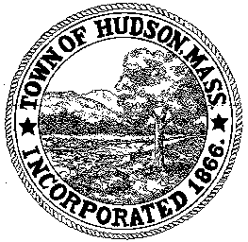

CONSERVATION COMMISSION
78 Main Street, Hudson, MA 01749
(978) 562-2020

Paul Byrne, Chairman W. Minot Wood, Vice Chairman David Esteves, Member

Terrence Joyce, Member Leif Longtine, Member Joseph Rodrigues, Member Al Tashian, Member

Meeting Agenda
November 4, 2010 7:00 P.M.

- Preliminaries
  - Open Meeting
  - Roll Call

2.0 Hearings and Appointments
2.1 DEP 190-536 Sign Order of Conditions
Applicant: Conray Wharff
Location: Lake Boon
Project Description: Drawdown

2.2 DEP 190-0555 Sign Order of Conditions
Applicant: Town of Hudson
Location: Houghton Court

23 11 Otsego Drive

2.4 Highland Commons
Removal of debris

3.0 New Business

- Old Business
  - Minutes October 21, 2010

- Adjournment

Next Meeting: November 18, 2010

